# Department of Computing

**Name : Usama Ejaz**

**Cms ID: 247644**

**CS-344: Web Engineering**

**Class:** BESE-9AB

# Lab 02: HTML Basics

**Date: October 22, 2020**

# Instructor: Dr. Qaiser Riaz

# 

# Lab 02: HTML Basics

### Introduction:

HTML is the standard markup language for creating web pages and web applications. During lectures, students have learned the structure of an HTML document and basic HTML tags. In this lab, students will practice the basic HTML tags.

### Lab Objectives:

The objective of this lab is to help students in building a single page website using basic HTML tags. Students will apply the basic HTML tags such as tables, links, lists etc. to create single page web site.

### Tools:

Dreamweaver, notepad, browser.

### Helping Material:

W3Schools: <https://www.w3schools.com/html/default.asp>

HTML Links: <https://www.w3schools.com/html/html_links.asp>

HTML Lists: <https://www.w3schools.com/html/html_lists.asp>

HTML Tables: <https://www.w3schools.com/html/html_tables.asp>

### Lab Task

### Task 1

Lists are important tags to display text in a list format. Get yourself familiarized with the basic concepts of lists (link is given above) and create an HTML page similar to the one given below:

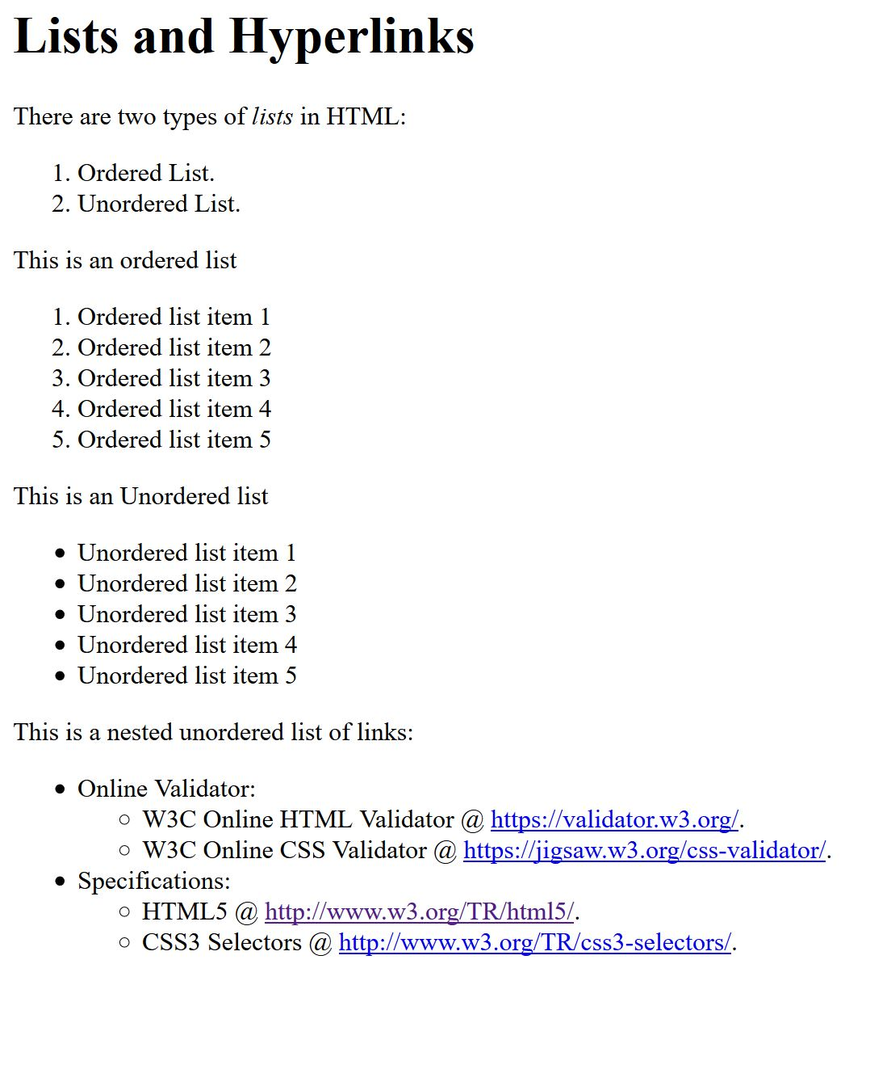

### Task 2

In HTML, it is possible to display text in tables and for this purpose <table> tag is used. Get yourself familiarized with the basic concepts of tables (link is given above) and create an HTML page which is showing your semester schedule in tabular format. An example is given below:

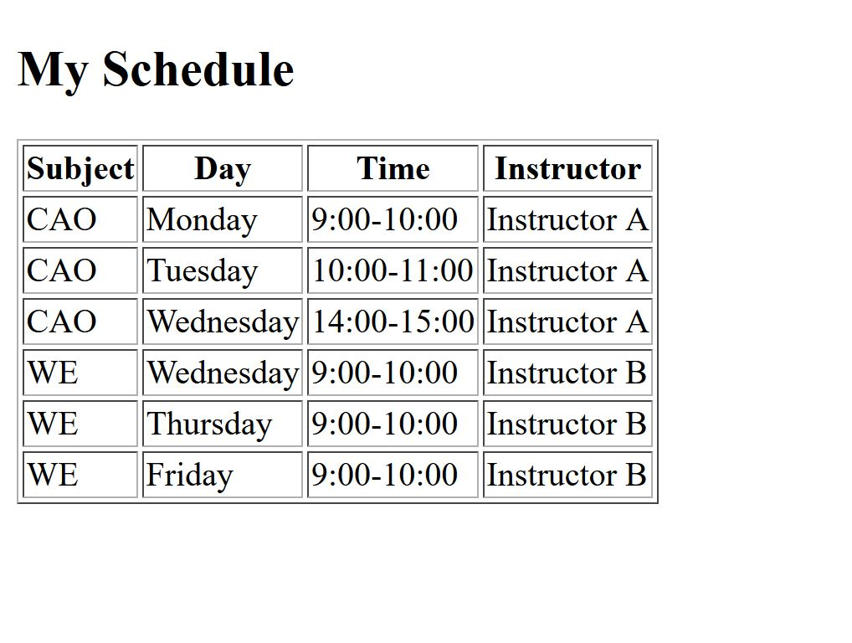

|  |
| --- |
| Solution |
| Screenshot of all HTML pages (Task 1, Task 2)    C:\Users\uejaz\Desktop\5th sem\Web\Labs\Lab 2\s2.JPG  HTML Code: Task 1  <!DOCTYPE html>  <html>      <head>          <title>Lists and Hyperlinks</title>      </head>      <body>          <h1>Lists and Hyperlinks</h1>          <p>There are two types of <em>lists</em> in HTML:</p>          <ol>              <li>Ordered List.</li>              <li>Unordered List.</li>          </ol>          <p>This is an ordered list</p>          <ol>              <li>Ordered list item 1</li>              <li>Ordered list item 2</li>              <li>Ordered list item 3</li>              <li>Ordered list item 4</li>              <li>Ordered list item 5</li>          </ol>          <p>This is an ordered list</p>          <ul>              <li>Unordered list item 1</li>              <li>Unordered list item 2</li>              <li>Unordered list item 3</li>              <li>Unordered list item 4</li>              <li>Unordered list item 5</li>          </ul>          <p>This is a nested unordered list of links:</p>          <ul>              <li>Online Validator:                  <ul>                      <li>W3C Online HTML Validator @                          <a href=https://validator.w3.org/.>https://validator.w3.org/.</a>                      </li>                      <li>W3C Online CSS Validator @                          <a href=https://jigsaw.w3.org/css-validator/.>https://jigsaw.w3.org/css-validator/.</a>                      </li>                  </ul>              </li>              <li>Specifications:                  <ul>                      <li>HTML5 @                          <a href=https://www.w3.org/TR/html5/.>https://www.w3.org/TR/html5/.</a>                      </li>                      <li>CSS3 Selectors @                          <a href=https://www.w3.org/TR/css-selectors/.>https://www.w3.org/TR/css-selectors/.</a>                      </li>                  </ul>              </li>          </ul>        </body>  </html>  HTML Code: Task 2  <!DOCTYPE html>  <html>      <head>          <title>My Schedule</title>          <!-- <style>              table, th, td {                  border: 1px solid black;              }          </style> -->      </head>      <body>          <h1>My Schedule</h1>          <table border="1">              <tr>                  <th>Subject</th>                  <th>Day</th>                  <th>Time</th>                  <th>Instructor</th>              </tr>              <tr>                  <td>CAO</td>                  <td>Monday</td>                  <td>9:00-10:00</td>                  <td>Instructor A</td>              </tr>              <tr>                  <td>CAO</td>                  <td>Tuesday</td>                  <td>10:00-11:00</td>                  <td>Instructor A</td>              </tr>              <tr>                  <td>CAO</td>                  <td>Wednesday</td>                  <td>14:00-15:00</td>                  <td>Instructor A</td>              </tr>              <tr>                  <td>WE</td>                  <td>Thursday</td>                  <td>9:00-10:00</td>                  <td>Instructor B</td>              </tr>              <tr>                  <td>WE</td>                  <td>Friday</td>                  <td>9:00-10:00</td>                  <td>Instructor B</td>              </tr>              <tr>                  <td>WE</td>                  <td>Saturday</td>                  <td>9:00-10:00</td>                  <td>Instructor B</td>              </tr>          </table>      </body>  </html> |

### Deliverables

Compile a single word document by filling in the solution part and submit this Word file on LMS. You must include your name, ID, and class on first page. The lab grading policy is as follows: The lab is graded between 0 to 10 marks. For some of the labs, students have to present their solutions in a viva session. In case of any problems with submissions on LMS, you should contact your lab engineer Mr. Aftab Hussain by email at [aftab.hussain1@seecs.edu.pk](mailto:aftab.hussain1@seecs.edu.pk).